ADOPT-A-TRAIL PROGRAM

**GROTON TRAIL SYSTEM**

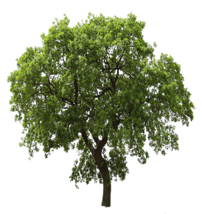

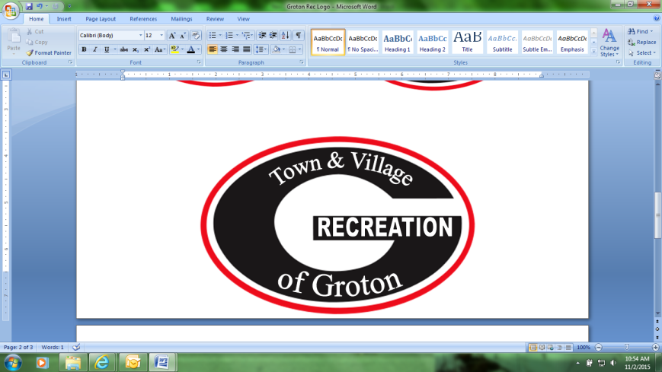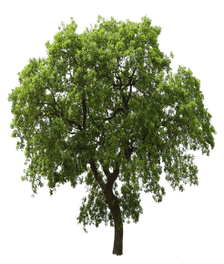****

Do you enjoy hiking on the trails in Groton? Do you have a favorite part of the trail system? Are you interested in caring for trails? The Adopt-a-trail program may be for you! Adopt-a-Trail is an all-volunteer program that gives the public an opportunity to be actively involved in conserving and maintaining the trail system throughout the Town and Village of Groton. Individuals or groups may adopt a trail or segment of a trail by volunteering their time to help keep the trail clean and safe. This program is open to community groups, businesses, churches and individual citizens.

DUTIES AND EXPECTATIONS

The expectation is that the volunteer(s) will monitor the trail section monthly from April through November. You would help trim back brush, clean up and remove trash, and report any further work needed to the Recreation Director. You serve as an extra set of eyes for the Recreation Department to watch for downed signs, damaged equipment, and vandalism. Regular maintenance will improve the appearance of your trail and make caring for it much easier!

DO YOU ENJOY THE GROTON TRAILS?

GET INVOLVED

If you would like to learn more or get the process started contact the Director of Recreation at recreation@grotonny.org or download our Adopt a Trail Application at www.grotonnyrecreaiton.com

RECOGNITION

Any interested organization, individuals and neighborhood groups can care for their "own" section of the trail. Adopt-a-Trail signs will be placed on the trails and in the parks to recognize those volunteers who have taken part of their valuable time to keep our trails clean and preserving this valuable asset for the community.

**GROTON TRAIL SYSTEM**

ADOPT-A-TRAIL PROGRAM APPLICATION

|  |  |
| --- | --- |
| **Name of Applicant:** | |
| **Adopting as group, please specify group name, business, or organization:** | |
|  | |
| **ADOPTER INFORMATION** | **Group/ Business/ Organization Details** |
| **Name:** | **Name:**  **Main Contact:** |
| **Phone(s):** | **Phone(s):** |
| **Address:** | **Address:** |
| **Email:** | **Email:** |
| **ADDITONAL QUESTIONS:** | |
| **Why would you like to become an Adopt-A-Trial volunteer?** | |
| **Do you have a preferred section of trail? (based on availability)** | |
| **Adopter/Coordinator Signature:** | **Date:** |

*Once this application is completed, please submit to Becky Koenig, Director of Recreation, at (recreation@grotonny.org). You may also mail in the application or drop off in person at the Groton Village office (ATTN: Becky Koenig, Adopt-a-Trail Program, 308 Main Street, Groton, NY 13073). You will be contacted by the Recreation Office within 30 days.*

**GROTON TRAIL SYSTEM**

ADOPT-A-TRAIL PROGRAM AGREEMENT

This Groton Trail System Trail Adopt-a-Trail Agreement (hereinafter "Agreement") is made this day of _____________________________ , by and between Groton Recreation (hereinafter "Sponsor"), and

__________________________________________________________________________________ (the adopting organization or volunteer(s) hereinafter ''Adopter''), using the mailing address of.

Each Adopt-a-Trail volunteer must complete the ADOPT-A-TRAIL VOLUNTEER APPLICATION and read and sign the following guidelines. The Sponsor and Adopter will oversee all activities of Adopt-a-Trail volunteers working on the Trail segment. The Adopter and the Sponsor acknowledge the limits and potential hazards of the Adopt-a-Trail Program, and agree to the following terms and conditions:

Adopt-a-Trail activities permitted are regular inspections and monitoring of the trail segment and light maintenance work including, but not limited to, litter pickup, mowing, brush control (but not the use of herbicides), cutting, trimming and planting, maintaining landscape vegetation, leveling of the walkway and minor repairs or refurbishment of trail signs, and other trail needs. No work of any nature will be performed on water areas without written approval.

All volunteers under 18 years of age must be accompanied by a parent or guardian. Minors (ages 12-17) shall be supervised at all times - one supervisor is required for every six minors. Minors may not operate power equipment of any kind. It is recommended that an Adopter have a first aid kit available. The Adopter and volunteers should be familiar with nearby transportation and emergency service facilities and providers; a mobile phone is also recommended. It is recommended that an Adopter provide sufficient potable water for volunteers or that volunteers bring their own drinking water. Hand tools and other required materials and supplies will be provided by the Adopter, individual volunteers, or community sponsor. No Adopt-a-Trail volunteer's motor vehicle may be driven or parked on the Groton Trail System unless necessary to respond to a medical emergency. Vehicles should be parked at assigned trailhead areas.

The Adopter shall conduct activities at a frequency that will enhance the goal of providing a park like appearance along the adopted segment. The expected minimum frequency of inspections and trash pickup along the trail segment is once each calendar month from April through November. Visits are also encouraged during the winter season.

The Adopter shall regularly report to the Sponsor the accomplishments of volunteer monitoring and maintenance activities for each day on site, and the number of volunteer hours spent on those activities.

Groton Recreation will furnish and erect Adopt-a-Trail signs at the beginning and the end of the adopted segment.

This Agreement will be for a two-year period. This Agreement may be cancelled at any time within the two year term by the Adopter or Sponsor, with a 30 day notice to the other party to this Agreement. The Adopt-a-Trail Program may be terminated at any time, at the sole discretion of Groton Recreation.

The term of this agreement is valid from date from signature below through the subsequent two year period ending on ___________________________.

________________________________________

________________________________________ ________________________________________

Groton Recreation Director Date Groton Trail Sponsor Date

**GROTON TRAIL SYSTEM**

ADOPT-A-TRAIL PROGRAM

ADOPTER WORK REPORT

